Our company (NTT DATA Business Solutions) falls under the NTT organization, which is the third largest telecommunications company in the world headquartered in Tokyo, Japan. This organization structure provides our company a remarkable capability to scale and to serve companies such as {{customerShortName}} with experienced resources and product experts. Further details concerning the NTT Corporation structure, alignment of NTT DATA Business Solutions within the overall corporate organization, and overall NTT company performance and global presence can be seen on the following three graphics.

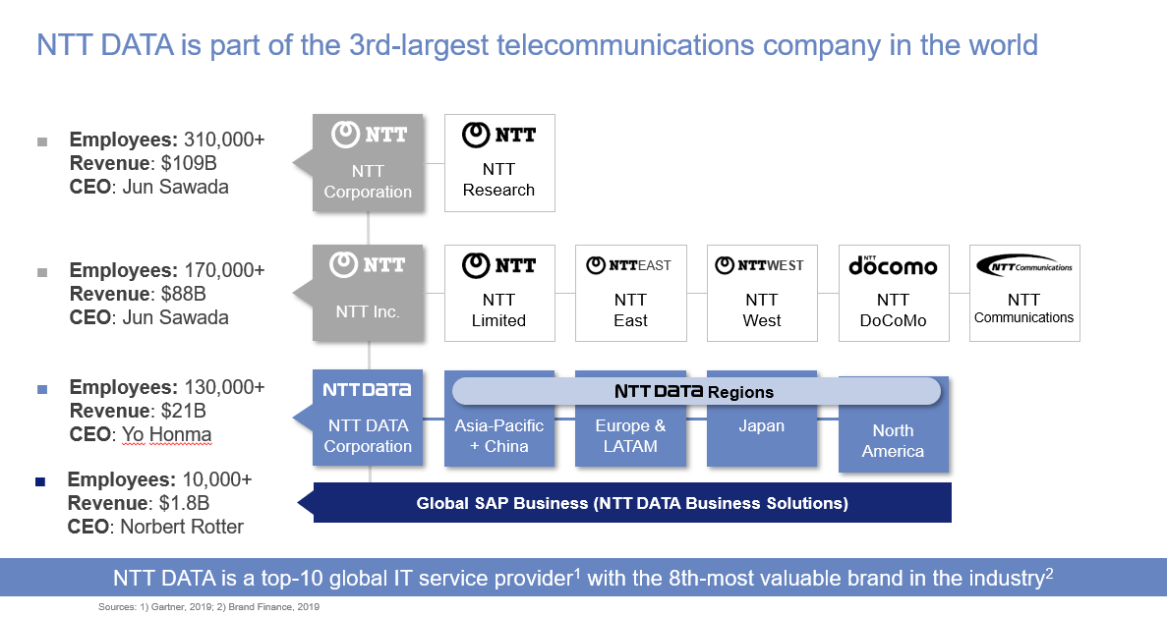As seen above, NDBS has over 880 S/4 HANA Projects and boasts over 1000 HANA DB clients. As early adopters of S/4, our consultants began practicing on S/4 early and it’s adoption has been a mainstay for almost 10 years. We expect all of them to be considered S/4 resources.

The NTT DATA relationship further strengthens our position from a geographic perspective as well as from a service offering perspective. Under the broader NTT DATA companies, we now have sister companies that specialize in areas outside of SAP (non-SAP IT solutions, etc.) so we can complement our service offerings to further support our client’s full IT landscape, which will be of benefit to {{customerShortName}}

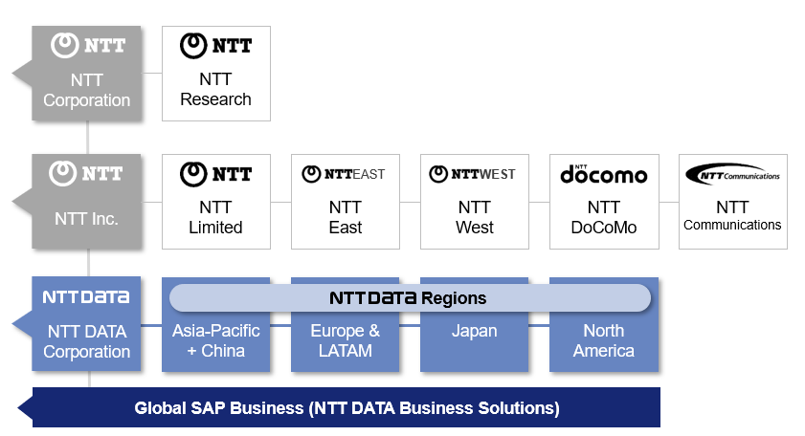

**NTT DATA | How we act as ONE in our global SAP business**